Apology Letter
Date: 01/05/25

To
M/s. YOGIS MEDITATION CENTER
Railway station backside,
Tenkasi road, Ambasamudram,
Tirunelveli - 627401.

Dear Sir,
Sub: Apologize for the inconvenience.
We sincerely apologize for the inconvenience you are experiencing with the smart attendance system. Please be assured that we are actively working to identify and resolve the core issue.
The prototype was rigorously tested under various conditions before delivery to ensure reliable performance. However, the current issue was unexpected. We have analyzed the system by testing it in two different locations (Office and Society). While it works normally in the Society setup, we observed intermittent issues in the Office.
Our preliminary assessment suggests that the high voltage level (measured at 247V, whereas the standard is 230V) may be affecting performance, as many appliances are designed to operate up to a maximum of 230–240V. To address this, we have ordered a power bank, which you will receive shortly.

We are committed to resolving this promptly and will share a detailed project report for your clarity. Once again, we apologize for the inconvenience caused and appreciate your patience and understanding.

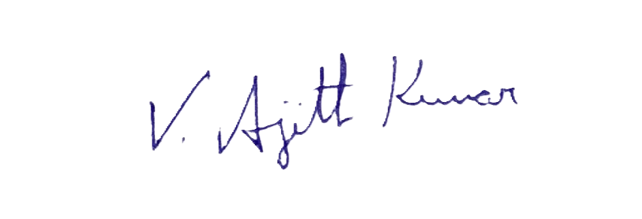For Shine Craft Technologies.,


(Ajith Kumar V)
Founder and COO

